**Mobile Innovations for Global Challenges**

**jQuery Mobile**

**Part 1 – jQuery Mobile questions**

Read the lecture notes on jQuery Mobile.

**Question 1:** What is the difference between mobile native and mobile web development?

A Native App is an app developed essentially for one particular mobile device and is installed directly onto the device itself.

A Web App, on the other hand, are basically Internet-enabled apps that are accessible via the mobile device’s Web browser. They need not be downloaded onto the user’s mobile device in order to be accessed.

**Question 2:** Provide an example of an app from Google Play developed with mobile web technology.

NYTimes – Latest News is an APP which developed with mobile web technology.

<https://play.google.com/store/apps/details?id=com.nytimes.android>

**Question 3:** Provide an example of an app from Google Play developed with native technology.

Angry Birds is an APP which developed with mobile native technology.

<https://play.google.com/store/apps/details?id=com.rovio.baba>

**Question 4:** Provide 4 names of mobile web browsers.

Chrome, Safari, UC Browser, Firefox

**Question 5:** Install Opera Mobile Emulator <http://www.opera.com/developer/mobile-emulator> and access <http://seneweb.com> from it. What do you notice? Explain. Provide at least one screenshot.

Please provide this document with your answers.

This website is not a responsive one.

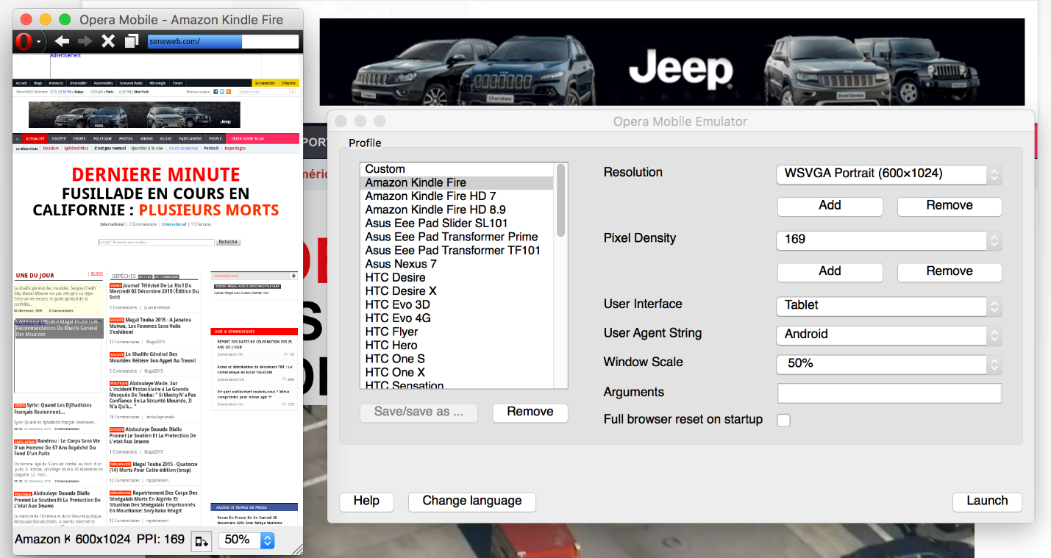

**Part 2 – Develop a jQuery Mobile web site**

Create a mobile web site with jQuery Mobile about AppDock based on the design provided here:

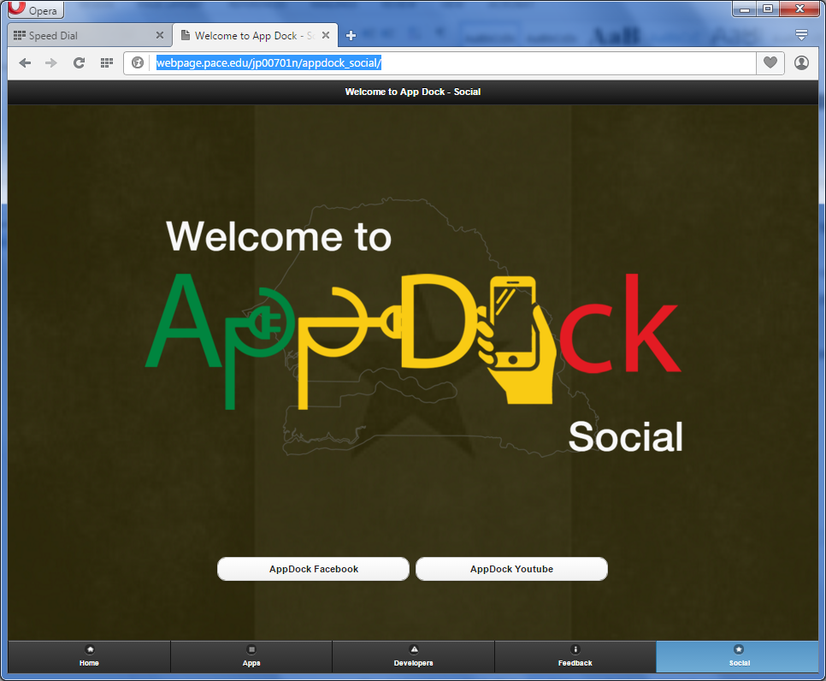

Here is the link for the team project:

<http://webpage.pace.edu/jp00701n/appdock_social/>

We worked on GitHub. <https://github.com/Luna2873/appdock_social> and <https://github.com/pangjie/appdock_social/pulse>

**Part 3 – Package the mobile web site into an app**

You will use Intel XDK to do so.

<https://software.intel.com/en-us/intel-xdk>

The Android app (apk file) should be available in GitHub.

Provide the URL to access the apk file in GitHub.